[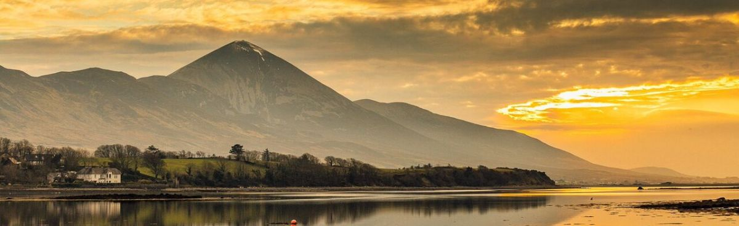](https://www.harlequinhotel-castlebar.com/croagh-patrick.html)[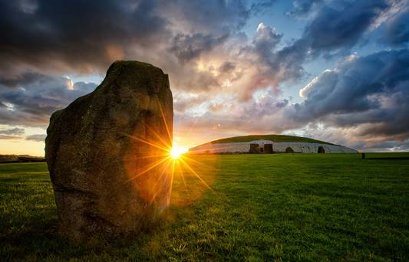](https://www.google.ie/url?sa=i&rct=j&q=&esrc=s&source=images&cd=&cad=rja&uact=8&ved=2ahUKEwiAsO2EuZvaAhWHDsAKHQxcDbwQjRx6BAgAEAU&url=https://www.independent.ie/life/travel/ireland/newgrange-watch-a-live-stream-of-the-spectacular-winter-solstice-36424833.html&psig=AOvVaw2A6VDlq6miExrSZGUwt7Vb&ust=1522753508565498)

**A Sacred Island Before Christianity**

**The impression that Ireland was a remote, isolated place in antiquity is outdated. Latest evidence suggests it was part of an active trade network along Atlantic-Mediterranean seaways. During the Neolithic and Bronze ages, the sea was a corridor for trade, communication, ideas & beliefs - easier, faster & more economical than overland routes.**

**In reality this made ancient Ireland ‘central & accessible’ - it’s west coast & islands part of a continuous maritime corridor, from the Mediterranean to Scandinavia. Seagoing Irish had intense cultural affinity & contact with other communities along this long seaboard. The result was; shared maritime heritage, language & religious beliefs.**

**Against this backdrop, Alf Monaghan traces the origin and spread of Pre-Christian eastern religious beliefs to Ireland, and their impact here. In this context too, the influence of Egyptian Christianity on the early Irish Church, is easily understood.**

**This is a fascinating ‘backstory’ to his earlier talk; ‘*Monastic Ireland - A Gift of the Nile!’***



**ALF MONAGHAN**

**Alf, from Carrick-on-Shannon, has spent most of his life abroad.**

**He has worked as an Economic Adviser to governments & development agencies in; Northern Europe, Central America, the Mediterranean, the Middle East, South & West Africa.**

**His years in Syria, Turkey, Lebanon, Cyprus, Jordan & Egypt, triggered a deeper interest in the origins of belief and religion.**

